

SOFTWARE REQUIREMENT SPECIFICATION
Project Name: Ralsei Coach House System
Project Code: RCHS

– Hanoi, May 2026 –
Table of Contents
I. Record of Changes 3
II. Software Requirement Specification 4
1. Overall Requirements 4
1.1 Context Diagram 4
1.2 Main Business Processes 4
1.3 User Requirements 4
1.4 System Functionalities 12
1.5 Entity Relationship Diagram 15
2. Use Case Specifications 17
2.1 Booking ticket 17
2.1.4 Package booking 22
2.2 Xyz Feature 22
3. Functional Requirements 23
3.1 Feature Name1 23
3.2 User Authentication 23
3.3 System Administration 24
4. Non-Functional Requirements 25
4.1 External Interfaces 25
4.2 Other Requirement 25
5. Requirement Appendix 26
5.1 Business Rules 26
5.2 System Messages 27
5.3 Other Requirements… 27

I. Record of Changes
Date | A*  M, D | In charge | Change Description
25/05 | A | Đức | 1.3.1 Actors  1.3.2 Use Case Diagrams
25/05 | A | Thành | 1.1 Context Diagram  1.4.1 Screens Flow
28/05 | A | Hà | 1.5 Entity Relationship Diagram
08/07 | M | Hà | 1.1 Context Diagram  1.3 User Requirements  1.4 System Functionalities  1.5 Entity Relationship Diagram
*A - Added M - Modified D - Deleted

II. Software Requirement Specification

1. Overall Requirements

1.1 Context Diagram
Ralsei Coach House System (RCHS) is a web-based coach passenger and cargo transportation management system designed to support routes operating between Quang Tri and Hanoi. The system provides public trip discovery and online passenger booking services while also supporting cargo transport operations.
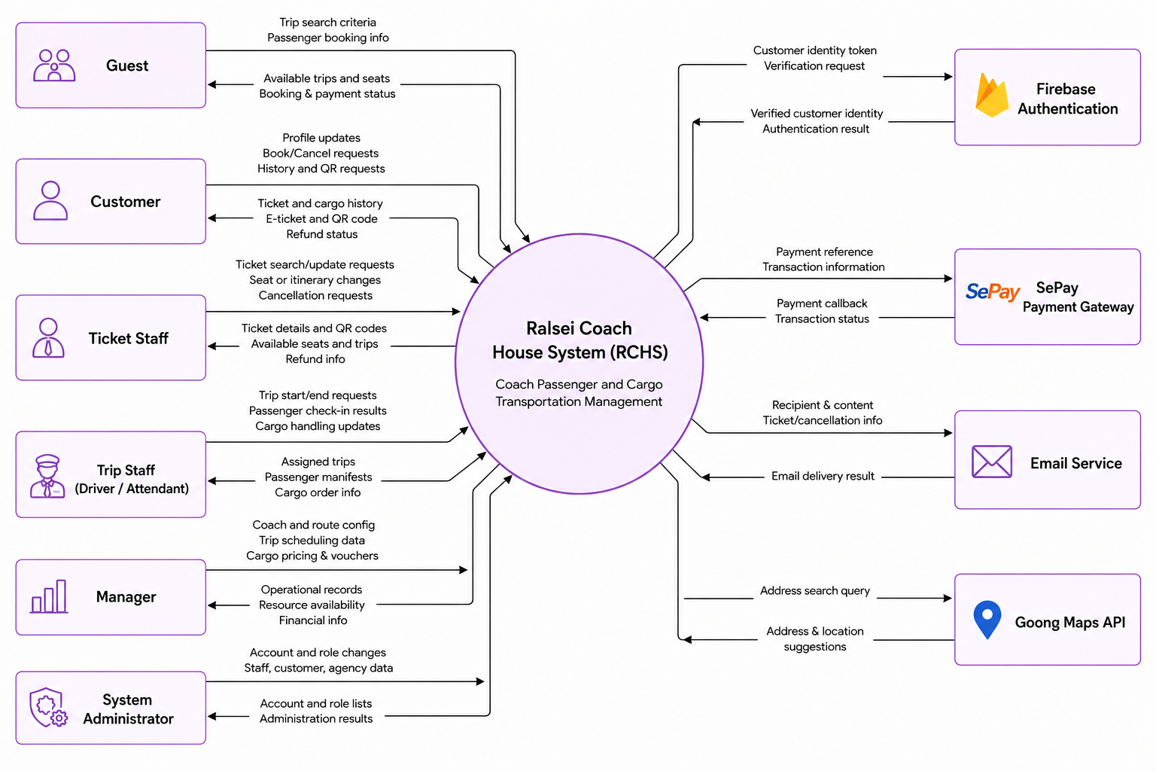

1.2 Main Business Processes

1.2.1 Online Passenger Ticket Booking Process
Vẽ swimlane

1.2.2 Passenger Boarding & Trip Execution Process
Vẽ swimlane

1.2.3 End-to-End Cargo Handling & Delivery Process
Vẽ swimlane

1.2.4 Counter Ticket Modification & Refund Process
Vẽ swimlane

1.3 User Requirements

1.3.1 Actors
# | Actor | Description
1 | Guest | Unauthenticated visitor on the Customer Site who can search, filter, and book trips, make payments.
2 | User | An abstract base actor representing any authenticated individual. Handles core account features including login, logout, password recovery, and personal profile management.
3 | Customer | Registered passenger (specializes Guest and User). Can register via Firebase Authentication, book tickets online, complete online payment, view booking history (passenger tickets and cargo orders), open ticket details, cancel eligible tickets, and display QR codes when qualified.
4 | Ticket Staff | Ticketing-office staff (specializes User). Manages passenger tickets (search, view detail, book at counter, cancel, change seat, transfer trip, update passenger info), manages cargo orders across lifecycle stages (view, create, assign to trip, track pending/in-transit/arrived, confirm delivery, collect payment), and views operational trip information.
5 | Trip Staff | On-board operational staff such as drivers and attendants (specializes User). Views assigned trips, marks their assigned trip as in-progress or completed, performs pre-departure duties (passenger check-in, cargo loading), and performs arrival duties (cargo unloading).
6 | Manager | Operations supervisor (specializes User). Manages trip scheduling, coach type configuration and pricing, individual coaches and seat layouts, route network and stop points, cargo catalog and freight pricing, voucher campaigns, and finance operations including pending refund review and confirmation.
7 | System Admin | Highest-level administrator (specializes User). Manages system accounts (view, lock/unlock, reset password, assign roles), view roles, staff onboarding and profile/status updates, customer records, and ticket agency records.
8 | SePay | External payment provider. Receives payment requests from the system, processes online transactions, and sends payment callbacks (IPN/webhook) with final transaction status.
9 | Email Service | External notification channel. Sends automated outbound messages such as ticket confirmations, cancellations, and other system-triggered emails to users.
10 | Goong Map | External location and mapping service provider handling operations such as address searching/autocomplete.

1.3.2 Use Cases (UC)
ID | Use Case | Feature | Use Case Description
 | Register Customer Account | Identity Management | Allows a guest to register a customer account using their phone number as the main medium to access online booking services.
 | Login | Identity Management | Allows users to log securely into their respective system portals based on their assigned roles.
 | Logout | Identity Management | Allows logged-in users to safely sign out of the system.
 | Forgot Password (Staff Only) | Identity Management | Allows staff to request a temporary password via email if they forget their login credentials.
 | View Personal Profile | Identity Management | Allows users to view their saved personal information and account details.
 | Update Personal Profile | Identity Management | Allows users to update their personal contact information.
 | Change Password (Staff Only) | Identity Management | Allows staff members to securely change their current password.
 | Create New Coach Type | Coach Configuration Management | Allows a manager to define a new coach template, including its seating layout and base ticket price.
 | Create New Coach | Coach Configuration Management | Allows a manager to add a physical coach to the fleet and link it to a specific coach type.
 | View & Search Coaches | Coach Configuration Management | Allows a manager to view, search, and monitor the operational status of all coaches in the fleet.
 | View & Search Coach Types | Coach Configuration Management | Allows a manager to browse different coach types and their configurations.
 | Update Coach Info | Coach Configuration Management | Allows a manager to update a physical coach's details, such as its license plate or manufacturer, and mark certain seats as un/available.
 | Update Coach Type Info | Coach Configuration Management | Allows a manager to modify the template of a coach type, such as adjusting the seat map or pricing.
 | Update Coach Operational Status | Coach Configuration Management | Allows a manager to change a coach's status (e.g., active, maintenance, retired) to control its availability.
 | Schedule New Trip | Trip Scheduling Management | Allows a manager to create a new trip by assigning a route, coach, crew, and departure time.
 | Adjust Trip Schedule | Trip Scheduling Management | Allows a manager to modify an existing trip's schedule, assigned vehicle, or operating crew.
 | Cancel Scheduled Trip | Trip Scheduling Management | Allows a manager to cancel an upcoming trip and stop further ticket sales for it.
 | View & Search Trips | Trip Scheduling Management | Allows a manager to search and monitor all scheduled trips.
 | View & Search Refund Requests | Finance Management | Allows a manager to review pending refund requests resulting from cancelled tickets.
 | Process Refund Request | Finance Management | Allows a manager to process and finalize customer refund transactions.
 | ??? | Route Network Management
 | View & Search Cargo Types | Cargo Catalog Management | A manager views and filters cargo categories by name or operational status.
 | Create Cargo Type | Cargo Catalog Management | A manager defines a cargo category, its price and availability for shipment processing.
 | Update Cargo Type | Cargo Catalog Management | A manager updates a cargo category, its price and availability for shipment processing.
 | View & Search Available Vouchers | Voucher Management | Allows a manager to view detailed statistics and usage metrics for a specific voucher.
 | Create New Voucher | Voucher Management | Allows a manager to create a new promotional discount code with specific usage rules.
 | Update Voucher | Voucher Management | Allows a manager to modify the rules or expiration dates of an active voucher.
 | Deactivate Voucher | Voucher Management | Allows a manager to disable or remove a discount campaign.
 | Find Available Trips | Passenger Portal | Allows customers to search for available trips based on locations and travel dates.
 | Book Passenger Ticket Online | Passenger Portal | Allows customers to book seats, enter details, apply discounts, and pay online.
 | View Booking History | Passenger Portal | Allows customers to view their past and upcoming ticket reservations.
 | Cancel Passenger Ticket | Passenger Portal | Allows customers to self-cancel an upcoming ticket and request a refund.
 | Show Passenger QR for Check-in | Passenger Portal | Allows customers to access their digital boarding pass (QR code) for check-in.
 | View Cargo Order History | Passenger Portal | Allows customers to track their cargo shipments and order history.
 | Sell Passenger Ticket at Counter | Ticket Operation Management | Allows ticket staff to book seats and process payments for walk-in customers at the counter.
 | View & Search Passenger Tickets | Ticket Operation Management | Allows staff to search for and view details of specific passenger bookings.
 | Cancel Passenger Ticket At Counter | Ticket Operation Management | Allows staff to cancel a customer's ticket and initiate the refund process.
 | Change Passenger Ticket Info | Ticket Operation Management | Allows staff to correct or update passenger details on an existing ticket.
 | Change Passenger Seat | Ticket Operation Management | Allows staff to move a passenger to a different seat on the same trip.
 | Transfer Trip | Ticket Operation Management | Allows staff to transfer passengers to a different trip and recalculate fare differences.
 | ??? cargo | Ticket Operation Management
 | Available Trip Lookup | Ticket Operation Management | Allows staff to look up available trips and schedules to assist customers.
 | View Assigned Trips | Trip Staff Operation | Allows drivers and attendants to view their assigned work schedules and trips.
 | Begin Trip | Trip Staff Operation | Allows trip staff to mark an assigned trip as started upon departure.
 | Complete Trip | Trip Staff Operation | Allows trip staff to mark an assigned trip as completed upon final arrival.
 | Verify & Check-in Passenger Ticket | Trip Staff Operation | Allows staff to scan QR codes or manually check in passengers during boarding.
 | Load Cargo | Trip Staff Operation | Allows staff to confirm that assigned cargo has been loaded onto the coach.
 | Unload Cargo | Trip Staff Operation | Allows staff to confirm that cargo has been unloaded at its destination.
 | View & Search Accounts | Account & Role & Employee Management | Allows an administrator to view and manage all registered system accounts.
 | Lock / Unlock Account | Account & Role & Employee Management | Allows an administrator to suspend or restore user access to the system.
 | Reset Account Password | Account & Role & Employee Management | Allows an administrator to manually reset a user's password.
 | Assign Roles to Account | Account & Role & Employee Management | Allows an administrator to grant or revoke specific system permissions (roles) for staff.
 | View System Roles | Account & Role & Employee Management | Allows an administrator to view available permission levels within the system.
 | View & Search Staff | Account & Role & Employee Management | Allows an administrator to browse the directory of all internal staff members and view staff details.
 | Onboard New Staff | Account & Role & Employee Management | Allows an administrator to register a new employee and create their system account.
 | Update Staff Info | Account & Role & Employee Management | Allows an administrator to update an employee's personal or professional details.
 | View & Search Ticket Agency | Ticket Agency Management | Allows an administrator to browse partnered ticket agencies.
 | Create New Ticket Agency | Ticket Agency Management | Allows an administrator to register a new partner agency and link it to a specific stop.
 | Update Ticket Agency Info | Ticket Agency Management | Allows an administrator to update a ticket agency's operational details.
 | View customer records | Customer Records | Allows an administrator to browse registered customers, view profiles, and track their history.

1.3.2 Use Case Diagrams

1.3.2.1 UCs for Guest
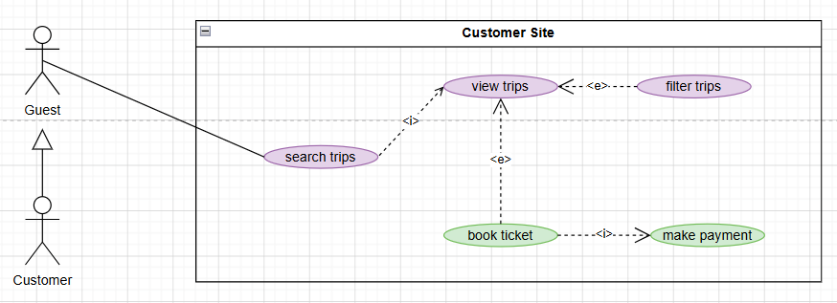

1.3.2.2 UCs for Customer
- Customer also extends all use cases of Guest.
- Customer also extends all use cases of User.
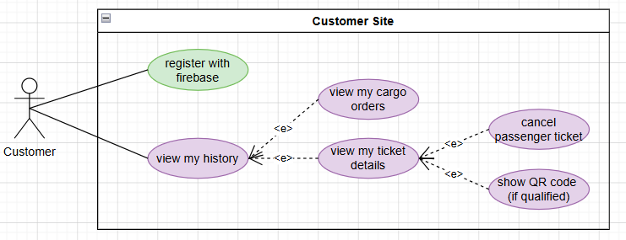

1.3.2.3 UCs for User
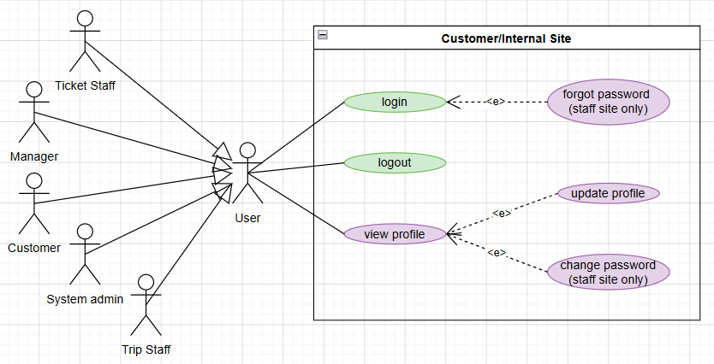

1.3.2.4 UCs for Ticket Staff
- Ticket Staff also extends all use cases of User.
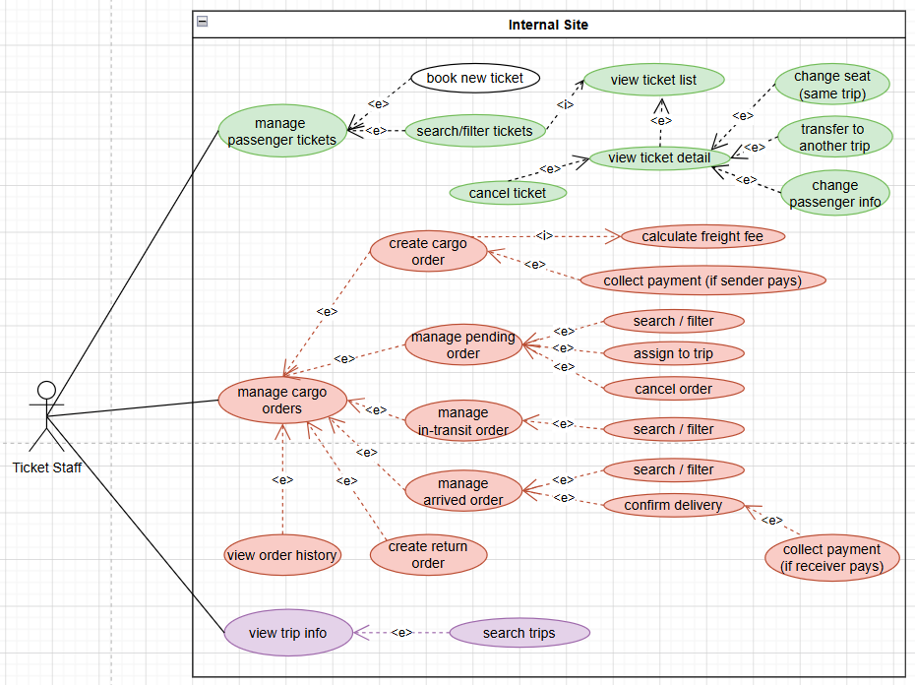

1.3.2.5 UCs for Trip Staff
- Trip Staff also extends all use cases of User.
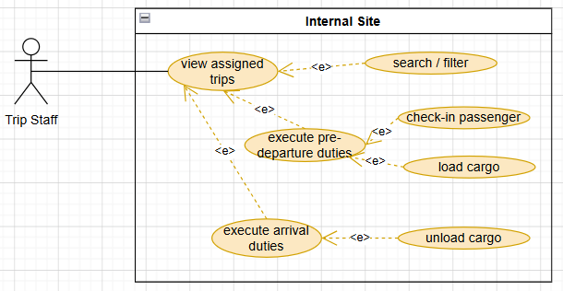

1.3.2.6 UCs for Manager
- Manager also extends all use cases of User.
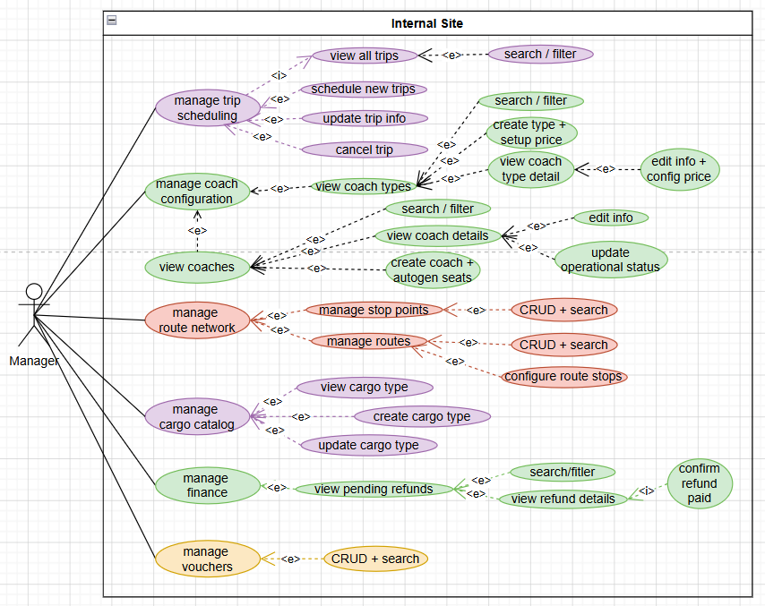

1.3.2.7 UCs for System Admin
- System Admin also extends all use cases of User.
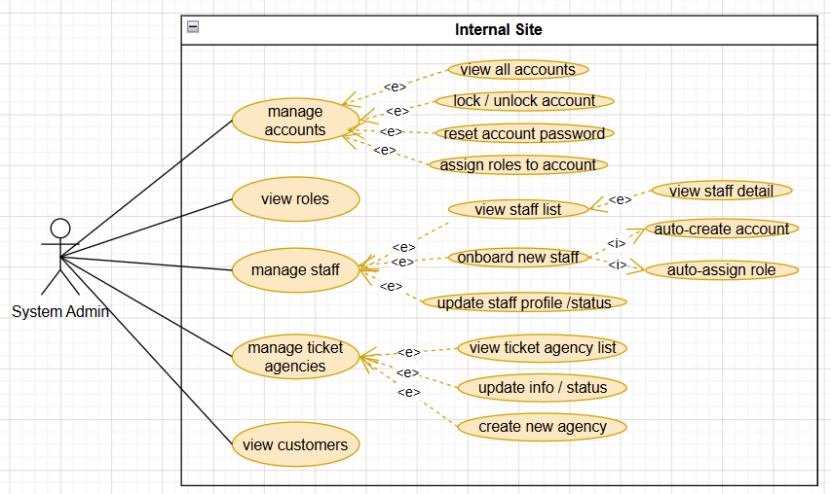

1.4 System Functionalities

1.4.1 Screens Flow
1.4.1.1 Customer Screen Flow
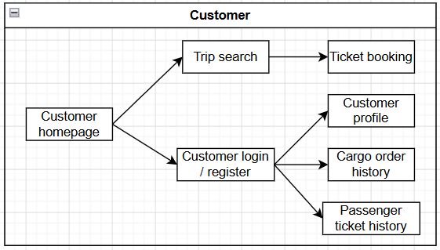
1.4.1.2 Trip Staff Screen Flow
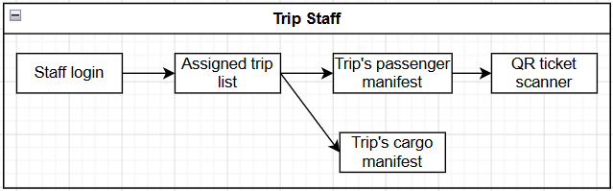
1.4.1.3 Ticket Staff Screen Flow
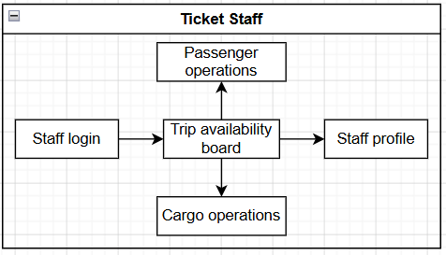
1.4.1.4 Manager Screen Flow
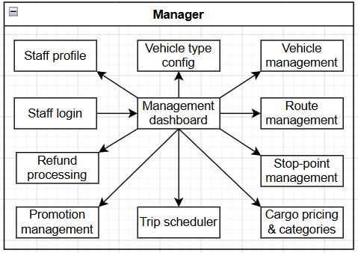
1.4.1.5 Admin Screen Flow
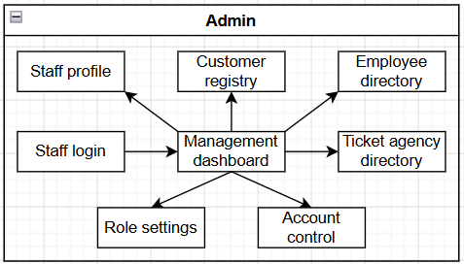

1.4.2 Screen Authorization
Screen | Ano-  nymous | Customer | Manager | Admin | Ticket Staff | Trip Staff
Customer homepage | X | X
Customer login/register | X | X
Trip search | X | X
Ticket booking | X | X
Customer profile |  | X
Cargo order history |  | X
Passenger ticket history |  | X
Staff login |  |  | X | X | X | X
Assigned trip list |  |  |  |  |  | X
Trip’s passenger manifest |  |  |  |  |  | X
QR ticket scanner |  |  |  |  |  | X
Trip’s cargo manifest |  |  |  |  |  | X
Staff profile |  |  | X | X | X | X
Trip availability board |  |  |  |  | X
Passenger operations |  |  |  |  | X
Cargo operations |  |  |  |  | X
Management dashboard |  |  | X | X
Vehicle type configuration |  |  | X
Vehicle management |  |  | X
Route management |  |  | X
Stop-point management |  |  | X
Cargo pricing & categories |  |  | X
Trip scheduler |  |  | X
Promotion management |  |  | X
Refund processing |  |  | X
Customer registry |  |  |  | X
Employee directory |  |  |  | X
Ticket agency directory |  |  |  | X
Account control |  |  |  | X
Role settings |  |  |  | X

1.4.3 Non-UI Functions
# | Feature | System Function | Description
1 | Identity Management | Firebase Customer Token Verification | Verifies Firebase ID tokens during customer login and registration, then links the verified identity to the corresponding backend customer account.
2 | Identity Management | Firebase Phone OTP Verification | Verifies Firebase phone OTP tokens during guest booking so unregistered passengers can confirm ownership of a phone number before ticket confirmation.
3 | Identity Management | JWT Authentication and Refresh Service | Issues JWT access and refresh tokens for authenticated users, validates tokens on protected API requests, and supports token refresh and logout.
4 | Identity Management | Staff Forgot-Password Email Dispatch | Generates a temporary staff password and sends it through the email service when the submitted username and staff email match an active account.
5 | Passenger Portal | Redis Seat Hold and Release Service | Temporarily locks selected seats in Redis during online booking and staff seat-change flows to prevent concurrent double-booking.
6 | Passenger Portal | Booking Price Calculation Service | Calculates passenger fare, applies eligible voucher discounts, and returns the final payable amount before booking confirmation.
7 | Passenger Portal | Passenger Booking Confirmation Service | Persists confirmed passenger bookings, initializes pending payment records, and prepares bank-transfer / SePay checkout information.
8 | Passenger Portal | Payment Status SSE Stream | Maintains a Server-Sent Events channel that pushes real-time payment status updates to the customer payment page.
9 | Passenger Portal | Pending Payment Expiry Scheduler | Periodically scans overdue pending passenger payments and expires unpaid booking sessions, releasing held seats and restoring voucher usage when applicable.
10 | Passenger Portal | Customer Ticket QR Retrieval Service | Generates and returns boarding QR image data for eligible customer-owned ticket seats.
11 | Passenger Portal | Customer Cargo History Lookup Service | Retrieves authenticated customer cargo order history records for the cargo history screen without requiring a separate tracking portal.
12 | External Payment Service | SePay Transaction ID Generator | Generates unique payment transaction identifiers in the PAYxxxxxx format used for SePay checkout matching.
13 | External Payment Service | SePay IPN Callback Processor | Receives SePay payment webhooks, validates the API token, confirms successful passenger payments, and triggers post-payment ticket confirmation actions.
14 | External Payment Service | Payment Transaction Lookup API | Returns payment transaction status for checkout monitoring and payment-page synchronization.
15 | External Email Service | Ticket Confirmation Email Sender | Sends HTML ticket confirmation emails containing trip, passenger, payment, and inline boarding QR information after successful payment.
16 | External Email Service | Ticket Cancellation Email Sender | Sends cancellation notification emails containing cancelled-ticket and refund information after customer or staff cancellation is confirmed.
17 | External Email Service | Refund Completed Email Sender | Sends a refund-completion notification email when a pending refund request is marked as completed by staff.
18 | Route Network Management | Goong Address Autocomplete Proxy | Proxies address autocomplete requests to the Goong Maps API to support coach-stop creation and editing.
19 | Ticket Operation Management | Boarding QR Token Generator | Generates unique boarding QR tokens that are embedded into passenger ticket details after successful payment.
20 | Ticket Operation Management | Boarding QR Image Generation Service | Converts boarding QR tokens into PNG QR images for customer history, staff ticket detail, and email attachments.
21 | Ticket Operation Management | Redis Ticket Code Generator | Generates unique passenger ticket codes using Redis-backed sequencing to avoid duplicate ticket identifiers.
22 | Ticket Operation Management | Staff Ticket Change Orchestration Service | Applies seat changes, passenger-info updates, and itinerary transfers using seat locking and fare recalculation rules.
23 | Finance Management | Refund Request Creation Service | Creates pending refund records when eligible passenger tickets are cancelled by customers or ticket staff.
24 | Trip Scheduling Management | Weekly Trip Auto-Generation Scheduler | Runs a scheduled job to auto-generate upcoming weekly trip schedules when remaining schedule coverage falls below the configured threshold.
25 | Trip Scheduling Management | Trip Resource Availability Resolver | Resolves available coaches, drivers, and attendants when managers create or update trips.
26 | Trip Staff Operation | Trip Staff Check-in Validation Service | Validates ticket ownership and trip assignment before recording passenger check-in from QR scan or manual selection.
27 | Trip Staff Operation | Trip Lifecycle Status Update Service | Updates assigned trip status when trip staff starts or completes an operational trip.
28 | Trip Staff Operation | Cargo Lifecycle Update Service | Advances cargo order status through load, unload, and delivery steps for trips assigned to trip staff.

1.5 Entity Relationship Diagram
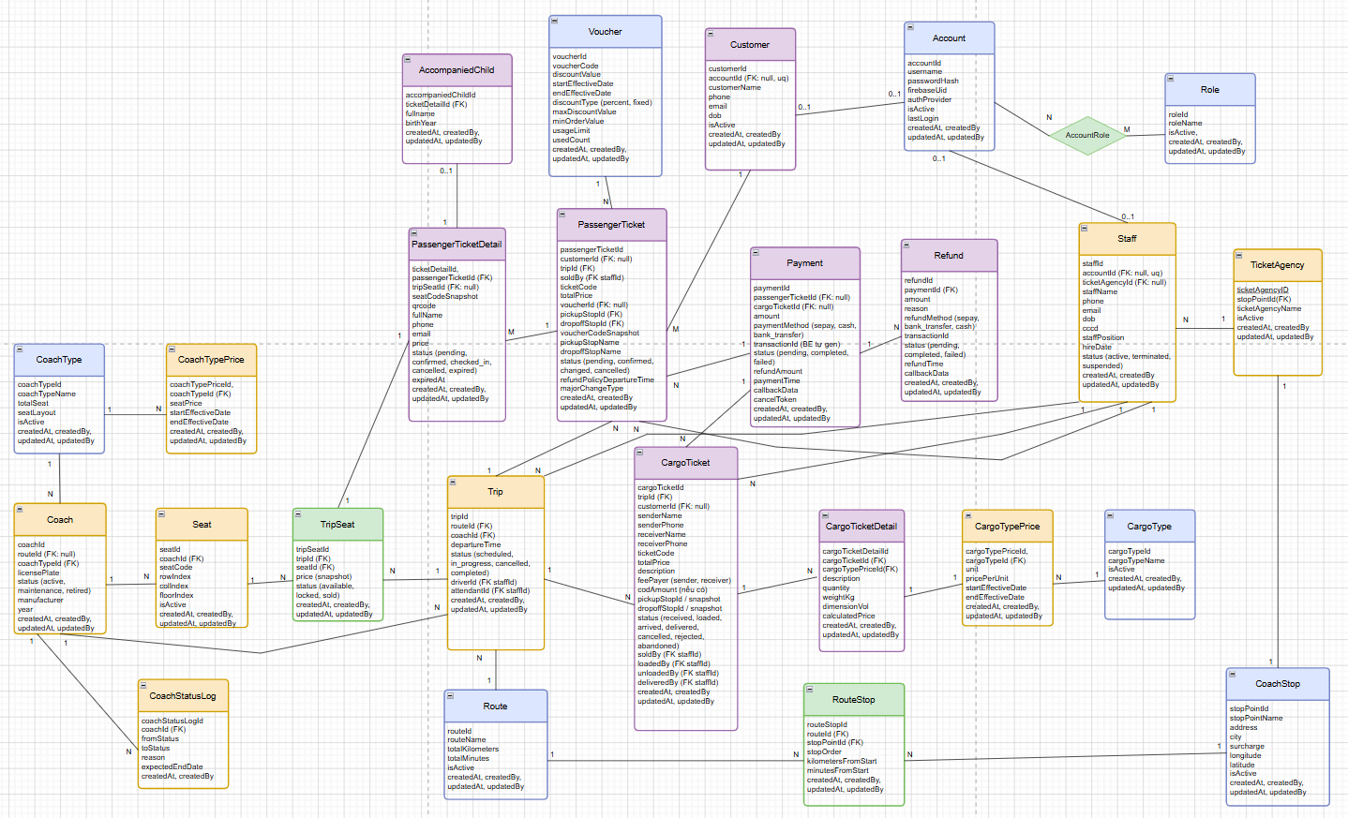
Entities Description
# | Entity | Description
1 | Account | Stores core authentication credentials. Supports local credential logins (username, passwordHash) for internal Staff, and external OAuth identity providers (firebaseUid, authProvider via Google/Facebook/Firebase Form) for Customers. Tracks status (isActive) and authentication timestamps.
2 | Role | Defines authorization security profiles and system access levels (e.g., SYSTEM_ADMIN, MANAGER, TICKET_STAFF, CUSTOMER) to enforce role-based access control (RBAC).
3 | AccountRole | An associative bridge entity handling the many-to-many relationship between Account and Role for granular multi-role mapping.
4 | Customer | Contains the personal profiles of external clients (customerName, phone, email, dob). Flexibly links to a unique Account (nullable to fully support guest checkouts for walk-in or unregistered passengers).
5 | Staff | Stores detailed internal employee records including contact info, cccd, hireDate, and specific system roles (DRIVER, ATTENDANT, TICKET_STAFF, MANAGER). Can optionally be assigned to a physical TicketAgency.
6 | TicketAgency | Represents physical branch offices or ticketing counters operated by the company, explicitly mapped to a definitive physical geographic CoachStop.
7 | CoachStop | Defines geographical stopping destinations (terminals, stations, rest stops) containing address matrices, city names, absolute GPS coordinates (latitude, longitude), and location-specific operational surcharge fees.
8 | RouteStop | An associative entity mapping a CoachStop to a Route. It establishes the sequential navigation blueprint (stopOrder), exact cumulative distance (kilometersFromStart), and driving timeline (minutesFromStart) from the point of origin.
9 | Route | Represents a structured logical journey connecting multiple stops, tracking global performance indicators including total transit distance (totalKilometers) and estimated driving duration (totalMinutes).
10 | CoachType | Categorizes vehicle specifications (e.g., VIP Limousine, Luxury Sleeper Bus) defining absolute seating capacities (totalSeat) and dynamic spatial grid layouts via a serialized blueprint field (seatLayout).
11 | CoachTypePrice | Manages baseline seat pricing matrices tied to specific CoachType configurations across strict effective timeline ranges to support dynamic seasonal or holiday pricing models.
12 | Seat | Represents a permanent, physical seat/bed structural asset inside a specific Coach, recording row/column vectors and a multi-level floor identifier (floorIndex) to support double-decker fleet configurations.
13 | Coach | Represents an active physical vehicle asset in the transport fleet identified by its unique licensePlate. Tracks production year, manufacturer, global status flags (ACTIVE, MAINTENANCE, RETIRED), and maps it to a default operating Route.
14 | CoachStatusLog | A system auditing entity that logs historical maintenance, breakdown, and lifecycle status mutations of a physical Coach (fromStatus, toStatus, reason, expectedEndAt).
15 | Trip | An active operational instance of a designated Coach driving a specific Route at a strict scheduled date and time (departureTime). Mandates the assignment of a distinct driverId and trip attendantId.
16 | TripSeat | An operational real-time snapshot tracking individual seat allocation statuses (AVAILABLE, LOCKED, SOLD) and frozen snapshot price variants for one specific scheduled Trip.
17 | PassengerTicket | The master transaction header for passenger bookings. Tracks the booking user, target Trip, processing employee (soldBy), total checkout costs, applied voucher identifiers, and safeguards data integrity via immutable point-in-time station name and refund policy snapshots.
18 | PassengerTicketDetail | Manages individual seat passenger assignments under a parent booking. Stores custom occupant details, generates unique validation qrcode strings, and hosts independent sub-lifecycle states (PENDING, CONFIRMED, CHECKED_IN, CANCELLED, EXPIRED).
19 | AccompaniedChild | Stores identification details of infants or minor children traveling alongside an adult passenger. Constrained to a strict one-child-per-seat structural allocation limit linked to a PassengerTicketDetail.
20 | CargoType | Categorizes classes of transportable goods and freight packages accepted by the logistics department (e.g., fragile electronics, motorbikes, documentation).
21 | CargoTypePrice | Defines systematic freight billing weights and measures rules (pricing formulas per kg, per m^3, or per individual package unit) across effective calendar dates.
22 | CargoTicket | The master transaction and operational record for a logistics shipment tracking comprehensive sender/receiver profiles, shipping fee payer liabilities (SENDER vs RECEIVER), Cash-on-Delivery (codAmount) liabilities, and processing staff handlers across the delivery chain.
23 | CargoTicketDetail | Represents a localized sub-parcel registry inside a master cargo shipment order, capturing explicit unit counts, physical weights, spatial volumes (dimensionVol), and derived cost metrics.
24 | Voucher | Defines promotional marketing campaign discount codes, enforcing percentage or fixed monetary reductions subject to minimum base order values, absolute deduction ceilings (maxDiscountValue), and absolute usage caps.
25 | Payment | Tracks incoming financial ledger transactions completed via multiple methods (SEPAY, CASH, BANK_TRANSFER). Enforces a strict exclusive constraint to link point-to-point to either one master PassengerTicket or one CargoTicket.
26 | Refund | Manages monetary chargebacks stemming from order cancellations or systemic adjustments, mapping transactions back to the source Payment record and tracking external payment gateway processing queues.
27 | RefreshToken | Manages secure authentication persistence and active user sessions by securely tracking cryptographic JSON Web Tokens (JWT) mapped to explicit Account references with expiration and revocation handles.

2. Use Case Specifications
Chỉ specify complex UCs involving in the main workflows (business processes)

2.1 Customer Feature

2.1.1 Online Passenger Ticket Booking
UC-ID, Name | UC01 - Online Passenger Ticket Booking
Primary Actors | Customer | Secondary Actors | Sepay, Email, Firebase
Description | As a traveler, I want to book a coach ticket, select the date, time, location I want to start/stop to manage my trip easily. I also want to book the seat, type of the coach and pay through QR code or bank transfer so that i can secure my seat without calling hotline or worrying about double booking
Preconditions | 1. The user has accessed the Ralsei Coach House booking website  2. Active bus routes, schedules and seat inventories are synchronized and available in the system.
Postconditions | 1. The selected seat status is updated to "Booked" in the global database.  2. Financial transactions are logged, and revenue is updated on the Owner's dashboard.  3. A unique e-ticket with a QR code is generated and sent to the customer.
Normal Sequence/Flow | - The customer search trip using the search bar at the home page to select date and start/end point.(See A6.1 and A6.2)  - The system will display all trips in the day that customer select (See A5.1)  - Customer request booking ticket at view trips  - Customer select seats  - The system show book ticket form (See A2.1 and 2.2)  - Customer confirm the booking  - The system calculate money total  - The system generate QR code for booking  - The customer scan QR code to make payment (See A4.1 and A4.2)  - The system show confirm “booking is successful", save booking to database, send message to confirm  - An Email with ticket information will be send to customer email, use case end with no error
Alternative Sequences/Flows | Alternative Flow  A2.1 get Customer information (if customer is logged in)  1. The system get Customer information in the account and auto fill ticket form using account data , continuing to step 5.  A2.2. Customer is not login  - The customer enter customer informations  - The system verify send OTP Message customer info (Phone Number)  - The customer enters OPT.  - Does the system check if the OTP is correct?(See A3.1 and A3.2).  - continuing to step 5.  A3.1. Customer enter the correct OTP  - The system will approve the phone number.  - The customer will continue to fill information.  - Return to step 4 (A2.2).  A3.2 Customer enter the incorrect OTP  - The system will reject the phone number.  - The customer must correct the correct phone number so the system can continue.  - return to step 4.  A4.1 The customer complete the QR Payment  - The system will accept the payment and add booking for customer  - Continue to step 9.  A4.2 The customer failed the QR Payment  - The system will reject the payment and reject the booking request.  - The customer will get a “Failed” notification and will be sent back to the home screen. Use case end with no error.  A5.1 The customer use filter trip  - The system will display according to price, coach type, start/end time, return to step 2  A6.1 The customer using the past search and the date still has not finished yet.  - The system will display the result like normal. Continue to step 2  A6.2 The customer using the past search and the date finished.  - The system will display “Không thể tìm chuyến trong quá khứ”. Use case end with no error  A7.1 Have an accompanying child.  - The system will display information for customer to enter the child information. Continue to step 5
Exception Flow | E1 – Network or Server Failure  - The login request cannot be completed because of a network or server issue.  - The system displays a generic login failure message.  - The user remains on the login page.

2.1.2 view history

Primary and Secondary Actors
An actor is a person or other entity external to the software system being specified who interacts with the system and performs use cases to accomplish tasks. Name the primary actor that will be initiating this UC and any other secondary actors who will participate in completing execution of the UC.
Description
Provide a brief description of the reason for and outcome of this use case, or a high-level description of the sequence of actions and the outcome of executing the use case. The description can be in the form of a user story (As a <type of user>, I want <some goal> so that <some reasons>)
Preconditions
List any activities that must take place, or any conditions that must be true, before the use case can be started.
Postconditions
Describe the state of the system at the successful conclusion of the use case execution.
Normal Flow
Provide a description of the user actions and corresponding system responses that will take place during execution of the use case under normal, expected conditions.
Alternative Flows
Describe below two information if any:
- Other successful usage scenarios that can take place within this use case. State the alternative flow, and describe any differences in the sequence of steps that take place.
- Any anticipated error conditions that could occur during execution of the use case and how the system is to respond to those conditions.

2.1.3 Login System
Firebase auth
Use case ID, Name | UC01 - User Login
Primary Actors | User, Guest | Secondary Actors | System, Database
Description | The user provides their phone number (username) and password on the login form. The system authenticates the credentials, determines the user's role, and redirects them to the appropriate landing page. If the user checks "Remember Me," their session persists across browser restarts.
User Story | As a registered user, I want to log in with my phone number and password so that I can access role-specific features and manage my bookings.
Preconditions | 1. The user must have a registered account in the `account` table.  2. The account must have at least one role assigned in `account_role`.  3. The corresponding `role` must exist in the `role` table.  4. The backend server must be running on port 9090.  5. The database connection must be active.
Postconditions | On success:  1. The user's `lastLogin` field in the `account` table is updated to the current timestamp.  2. A random UUID token is generated and returned in the response.  3. The user's identity (username + role) is stored in `localStorage` or  `sessionStorage` depending on "Remember Me."  4. The user is redirected to `/home`.  On failure:  1. No session data is persisted.  2. An appropriate error message is displayed on the login form.  3. The user remains on the login page.
Normal Sequence/Flow | Main Flow  - The user navigates to the Login page.  - The system displays the login form.  - The user enters their phone number and password.  - The user optionally selects “Remember Me”.  - The user clicks the Sign In button.  - The system validates the input fields.  - The system sends the login request to the backend.  - The system verifies the user credentials.  - The system checks whether the account is active.  - The system creates a login session and authentication token.  - The system stores the user session.  - The system updates the interface to reflect the logged-in state.  - The system redirects the user to the homepage.
Alternative Sequences/Flows | A1 - Invalid Credentials (Step 8)  - The system cannot verify the username or password.  - The system displays an error message.  - The user remains on the login page.  A2 - Account Disabled (Step 9)  - The system detects that the account is disabled.  - The system displays an account locked message.  - The user remains on the login page.  A3 - Remember Me Checked  - During the last login session, the user selected the “Remember Me” option.  - After successful authentication, the system stores the user session in persistent browser storage.  - The user remains logged in and the system redirect the user to homepage.
Exceptional Flow | E1 – Network or Server Failure  - The login request cannot be completed because of a network or server issue.  - The system displays a generic login failure message.  - The user remains on the login page.

2.1.4 Register System
Use case ID, Name | UC-02: User Registration
Primary Actors | User, Guest | Secondary Actors | System, Database
Description | A guest user registers a new account using a phone number and password in order to access the system and book bus tickets.  The user provides required registration information and optional personal details. The system validates the input, checks whether the phone number already exists, creates the account, assigns the Customer role, and stores the customer profile.
User Story | As a guest user,  I want to register an account using my phone number and password,  so that I can log in to the VeXeBus system and book bus tickets.
Preconditions | The Customer role exists in the system.  The backend server and database are available.  The phone number has not already been registered.
Postconditions | On Success:  - A new user account is created.  - The Customer role is assigned to the account.  - Customer profile information is stored.  - The user is redirected to the login page with a success message.  On Failure:  - No account information is stored.  - The system displays an appropriate error message.  - The user remains on the registration page.
Normal Sequence/Flow | Normal Flow  - The user navigates to /register.  - The system displays the registration form.  - The user enters a phone number and password.  - The user confirms the password.  - The user optionally enters CCCD and email information.  - The user clicks the Create Account button.  - The system validates the registration information.  - The system checks whether the phone number already exists.  - The system creates the user account.  - The system assigns the Customer role to the account.  - The system creates the customer profile.  - The system displays a registration success message.  - The system redirects the user to /login.
Alternative Sequences/Flows | A1: Duplicate Phone Number (Step 8)  - The system detects that the phone number already exists.  - The system displays an error message.  - The user remains on the registration page.  A2: Invalid Registration Information (Step 7)  - 3. The system detects invalid input such as:  - Passwords do not match  - Invalid phone number format  - Invalid CCCD format  - Invalid email format  - The system displays validation errors.  - The registration process stops until the user corrects the information.
Exceptional Flow | E1: Network or Server Failure  - The registration request cannot be completed because of a network or server issue.  - The system displays a registration failure message.  - The user remains on the registration page.  E2: System Error During Registration  - An unexpected system or database error occurs during registration.  - The system cancels the registration process.  - The system displays an error message.  - No incomplete account data is stored.

2.2.3 Logout System

Use case ID, Name | UC-03: User Logout
Primary Actors | Ticket Staff, Customer | Secondary Actors | System, Database
Description | A logged-in user creates a new cargo shipping order by entering sender information, receiver information, and one or more items with their quantities and weights. The system calculates the total price based on current cargo type prices, saves the order to the database, and returns a unique order code.
User Story | As a ticket staff member, I want to create a new shipping order so that I can register cargo transportation requests from customers and generate a tracking code for them
Preconditions | 1. The user is logged into the system.  2. The backend API is running.  3. The database is connected.  4. Cargo types and their current prices exist in the database.
Postconditions | On Success:  - The user session is cleared.  - Authentication data is removed from browser storage.  - The system returns to the login page.  - The interface updates to show logged-out options.  On Failure:  - No special failure handling is required because clearing an empty session does not cause errors.
Normal Sequence/Flow | Normal Flow  - The user clicks the Logout button.  - The system clears the current user session.  - The system removes stored authentication information.  - The system updates the application state to reflect that the user is logged out.  - The system redirects the user to /login.  - The interface re-renders and displays Login and Register options.
Alternative Sequences/Flows | A1: Session Already Cleared  - The system attempts to clear authentication data that does not exist.  - No error occurs.  - The logout process continues normally.

2.6 Manages Account

Use case ID, Name | UC05 - Manage Trip Schedule
Primary Actors | Customer | Secondary Actor | System database
User Story
Description | After a successful tracking lookup, the customer views the order's detailed information, including the status timeline, sender/receiver information, pickup/dropoff points, trip details, and the list of goods with prices.
Preconditions | 1. The tracking code lookup was successful.  2. Order data exists.
Postconditions | The customer understands the order's current status and detailed information.
Normal Sequences/Flow | 1. The system displays a 4-step status timeline: Received → Loaded onto vehicle → Arrived → Delivered.  2. The system displays 4 information cards: sender, receiver, pickup/dropoff point, trip.  3. The system displays an order summary card: tracking code, status, description, fee payer, COD, total fee.  4. The system displays a goods list table: description, quantity, weight (kg), volume (m³), unit of measure, amount.
Exceptional Flow | E1: No goods — If items = [], the goods table is hidden.  E2: No trip assigned — If tripRouteName = null, display "N/A".

3. Functional Requirements

3.0 Example: System Administration

3.0.1 Example: Master Data

3.0.1.1 Example: Setting List
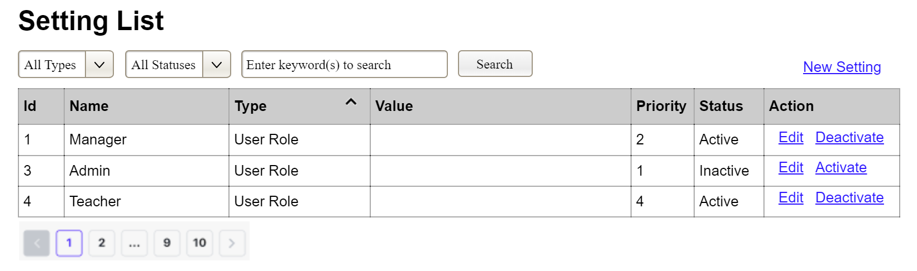
(1)
(2)
(3)
This screen allows the Administrator to:
- View Setting List: view list of current master data.
- Filter Setting List: filter master data by data types, statuses
- Search Settings: enter keyword(s) to search master data by their names or values
- Sort Setting List: sort master data list (ascending, descending) by clicking column headers
On the screen, s/he can also
- Activate/Deactivate Setting: change status of a specific inactive/active master data
- Choose to go to the Setting Details screens for adding new or updating an existing master data by clicking the New Setting or Edit link.
Field Description
Field Name | Description
(1) | Initial values: all the active setting names with null or blank type  Hover the mouse to show the field name: “Setting Type”
(2) | Initial values: All Statuses, Active, Inactive (default value “All Status”)  Hover the mouse to show the field name: “Setting Status”
(3) | The change-status action is Activate or Deactivate depending on the current status of the relevant setting (Inactive or Active, respectively).

3.0.1.2 Example: Setting Details
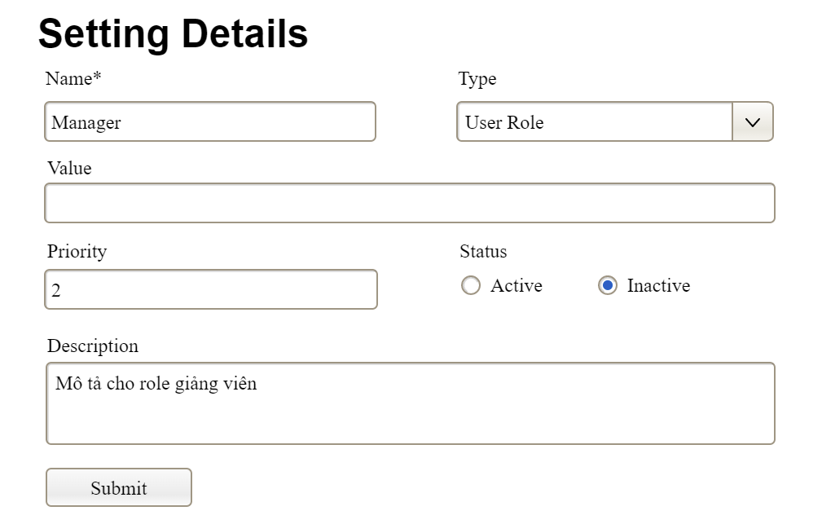
This screen allows the Administrator to:
- Add New Setting: add new master data.
- Update Setting Details: update details of a specific master data
Field Description
Field Name | Description
Name | Data type: non-digit string, max length of 20 characters
Type | Initial data values: all active setting names (with null or blank type)
Value | Data type: any string, max length of 100 characters
Priority | Data type: a positive integer
Description | Data type: any string, max length of 200 characters

3.0.2 Example: User Management

3.0.2.1 Example: User List

3.0.2.2 Example: User Details

3.1 Authentication & Profile Management
Info để xào nấu phần này:
- customer site: register, login, logout, manage profile (view profile, update profile)
- staff site: login(+forgot password), logout, manage profile (view profile, update profile, change password)

3.2 Customer Portal
Info để xào nấu phần này:
- FR 2.1 - Trip Search & Schedule Lookup: Allow customers to view the trip list and schedules.
- FR 2.2 - Online Ticket Booking: Reserve seats and select specific seats.
- FR 2.3 - View Ticket Booking History with Cancel Option: View the list of booked passenger tickets (Authentication Required).
- FR 2.4 - View Cargo Shipping History: View the status of cargo orders (Authentication Required).

3.3 Trip Operations
Info để xào nấu phần này:
- FR 3.1 - Track and Execute Assigned Trips: View the list of assigned trips to be operated. Can mark the trip status as started or ended.
- FR 3.2 - Passenger Manifest Management: View information of boarding passengers.
- FR 3.3 - QR Code Ticket Scanning: Use the camera to scan customers' QR codes for check-in. Manual check-in applicable.
- FR 3.4 - Trip Cargo Management: View the list of cargo loaded onto the vehicle. Can mark cargo status as loaded and unloaded.

3.4 Counter Operations
Info để xào nấu phần này:
- FR 4.1 - General Trip Lookup: View trips currently available for booking.
- FR 4.2 - Counter Ticket Management: View, Sell tickets at the counter, cancel tickets, and exchange tickets for customers.
- FR 4.3 - Counter Cargo Management: View, Receive goods, weigh/measure, calculate fees, and create cargo orders at the counter.

3.5 Manager Operations
Info để xào nấu phần này:
- FR 5.1 - Fleet Management: Manage coach types, coaches and pricing.
- FR 5.2 - Route Management: Manage routes, and coach stops.
- FR 5.3 - Trip Scheduling: Arrange and schedule trip timetables.
- FR 5.4 - Cargo Type Management: Manage cargo type and pricing.
- FR 5.5 - Promotion Management: Create and manage vouchers.
- FR 5.6 - Refund Processing: Approve ticket cancellation and refund requests.

3.6 Admin Operations
Info để xào nấu phần này:
- FR 6.1 - Account & Role & Employee Management: View, create staff accounts and assign roles, view role list,...
- FR 6.2 - Customer Accounts Directory: view only
- FR 6.3 - Ticket Agency Management: manage ticket agency

4. Non-Functional Requirements

4.1 External Interfaces

4.1.1 User Interfaces
RCHS provides two browser-based web interfaces:
Interface | Application | Target users | Primary devices
Customer Site | frontend-react (default port 3000) | Guest, Customer | Desktop and mobile browsers
Internal Staff Site | frontend-react-staff (default port 2999) | Ticket Staff, Trip Staff, Manager, Admin | Desktop browsers for management/ticket staff; mobile browsers for Trip Staff operational screens
UI requirements:
- The Customer Site shall support public trip search, online booking, payment status monitoring, authentication, profile management, ticket history, and cargo history.
- The Internal Staff Site shall support role-based navigation so that each staff role only sees authorized menus and screens.
- Trip Staff screens shall use a mobile-oriented layout suitable for on-trip operations (assigned trips, check-in, cargo handling).
- The UI shall display loading indicators during asynchronous API calls and shall show clear validation or error messages when requests fail.
- The UI language of the current product is primarily Vietnamese for end-user labels.
- The system shall provide unauthorized and not-found pages when users access restricted or unknown routes.

4.1.2 Hardware Interfaces
RCHS does not require specialized proprietary hardware. The following commodity devices are assumed:
Hardware | Purpose
Desktop / laptop computer | Customer booking and staff/manager administration
Smartphone / tablet | Trip Staff check-in and cargo handling; customer mobile browsing
Device camera | QR ticket scanning during Trip Staff check-in
Network interface (LAN/Wi-Fi/mobile data) | Communication with backend API and external services
Optional printer | Printing receipts or ticket information at ticket counters (manual / browser print; no dedicated printer driver integration)
Note: No POS terminal, barcode scanner hardware driver, or embedded device protocol is required by the current software design.

4.1.3 Software Interfaces
RCHS depends on the following software systems and components:
# | Software / Service | Interface type | Purpose
1 | Microsoft SQL Server | JDBC / JPA (Hibernate) | Persistent storage for accounts, trips, tickets, payments, cargo, and configuration data
2 | Redis | Redis protocol via Spring Data Redis | Temporary seat locks, booking hold sessions, and ticket-code sequencing
3 | Firebase Authentication | Firebase Admin SDK + client SDK | Customer registration/login and phone OTP verification
4 | SePay Payment Gateway | HTTPS REST webhook / IPN | Online payment confirmation for passenger bookings
5 | SMTP Email Service | SMTP over STARTTLS | Ticket confirmation, cancellation, refund completion, and staff forgot-password emails
6 | Goong Maps API | HTTPS REST | Address autocomplete for coach-stop management
7 | Web Browser (Chromium / Firefox / Safari / Edge current versions) | HTML5 / JS | Runtime for both Customer and Staff frontends
8 | Java Runtime (JDK 17) + Spring Boot | Application runtime | Backend API hosting
9 | Node.js + Vite React toolchain | Build/runtime tooling | Frontend development and packaging
Interface constraints:
- The backend shall expose a versioned REST API under /api/....
- External payment confirmation shall be accepted only through the SePay IPN endpoint with a valid API token.
- Firebase ID tokens shall be verified server-side before creating or authenticating customer sessions.
- Email delivery credentials shall be supplied through environment configuration and shall not be hard-coded in source control for production use.
- Goong API keys shall be kept on the backend proxy; the frontend shall not call Goong directly with a secret key.

4.1.4 Communications Interfaces
ID | Requirement
CI-01 | Standard client-server communication shall use HTTPS.
CI-02 | The backend development profile supports TLS via a PKCS12 keystore on port 9090.
CI-03 | REST APIs shall exchange data primarily in JSON over HTTP(S).
CI-04 | Payment status updates for online booking shall additionally use Server-Sent Events (SSE) (text/event-stream) for near-real-time UI refresh.
CI-05 | Email notifications shall be transmitted through SMTP with authentication and STARTTLS enabled.
CI-06 | SePay IPN callbacks shall be received through HTTPS POST and validated by API token before payment finalization.
CI-07 | Cross-origin browser access from the Customer Site and Staff Site to the backend API shall be permitted only for configured frontend origins.
CI-08 | Stateless authentication for protected APIs shall use JWT Bearer tokens in the HTTP Authorization header.

4.2 Quality Attributes

4.2.1 Usability
ID | Requirement
UR-01 | Guest users shall be able to search trips and start booking without creating an account.
UR-02 | The online booking flow shall be presented as a step-by-step wizard (seat selection → passenger information → payment).
UR-03 | Required form fields shall be clearly indicated, and invalid inputs shall produce inline or form-level error messages.
UR-04 | Authenticated customers shall access profile, ticket history, and cargo history from persistent navigation / account menus.
UR-05 | Staff users shall be redirected after login to a role-appropriate landing screen (Manager/Admin dashboard area, Ticket Staff ticket search, or Trip Staff trip list).
UR-06 | Trip Staff screens shall prioritize large touch-friendly actions for check-in and cargo status updates on mobile devices.
UR-07 | Destructive actions (ticket cancellation, voucher, trip cancellation,...) shall require explicit user confirmation before execution.
UR-08 | Long-running operations (payment waiting, history loading, seat map loading) shall display a loading state to avoid blank-screen ambiguity.
UR-09 | The system shall provide readable unauthorized (401) and not-found (404) pages instead of silent failures.
UR-10 | Staff forgot-password recovery shall be available from the staff login screen without administrator intervention for temporary password issuance.

4.2.2 Performance
ID | Requirement | Project basis
PR-01 | Database connection pooling shall be limited to a maximum of 20 concurrent connections. | HikariCP maximum-pool-size=20
PR-02 | Database connection acquisition timeout shall not exceed 30 seconds. | HikariCP connection-timeout=30000
PR-03 | Backend data access shall avoid N+1 query patterns for list/detail screens by using projections, joins, or batched queries where practical. | Account/login projection pattern and repository projections
PR-04 | Seat selection concurrency shall use Redis locks with TTL: 10 minutes during browsing/hold and 15 minutes during payment confirmation window. | BROWSING_HOLD_TTL_SECONDS=600, PAYMENT_HOLD_TTL_SECONDS=90
PR-05 | Overdue pending passenger payments shall be scanned and expired by a background scheduler approximately every 30 seconds. | PassengerPaymentExpiryScheduler
PR-06 | A customer may lock at most 10 seats in a single booking hold request. | @Size(max = 10) on seat lock request
PR-07 | Seat map and booking pages shall render incrementally with loading states; heavy seat-map rendering shall remain responsive for typical coach layouts used by the fleet. | Booking UI + seat map components
PR-08 | Frontend search/filter interactions that trigger remote calls should debounce or avoid redundant repeated requests where applicable. | Staff/customer list filter patterns
PR-09 | SMTP send operations shall use bounded timeouts (connection/read/write in the 5–10 second range) to prevent request threads from hanging indefinitely. | spring.mail.properties.mail.smtp.*timeout
PR-10 | JWT access tokens shall expire after 24 hours; refresh tokens shall expire after 7 days. | jwt.expiration=86400000, jwt.refresh.expiration=604800000
PR-11 | Payment SSE connections shall support the payment waiting window (emitter timeout configured around 15 minutes) and disconnect cleanly afterward. | PaymentSseServiceImpl
PR-12 | Sensitive cached values (when temporarily stored) shall not expose raw PII in logs; logging of tokens and secrets shall be avoided. | Logging / PII masking utilities

4.2.3 Security
ID | Requirement
SR-01 | All staff passwords shall be stored only as BCrypt password hashes; plaintext passwords shall never be persisted.
SR-02 | Customer authentication shall rely on Firebase-verified identity tokens; the backend shall reject unverifiable tokens.
SR-03 | Protected APIs shall require a valid JWT, except explicitly public endpoints (auth, public trip search, booking initiation, payment IPN, and selected public route lookups).
SR-04 | Authorization shall enforce role-based access control (RBAC) for Customer, Ticket Staff, Trip Staff, Manager, and Admin functions.
SR-05 | Inactive / locked accounts shall be denied authentication.
SR-06 | SePay IPN requests shall be rejected when the configured API token does not match.
SR-07 | HTTPS/TLS shall be used for browser-to-server and server-to-external-service communication in deployed environments.
SR-08 | Secrets (JWT signing key, SePay token, Goong key, mail password, SSL keystore password) shall be managed through configuration/environment variables and shall not be committed as production secrets.
SR-09 | Boarding QR images and ticket detail APIs shall verify ownership or staff authorization before returning passenger data.
SR-10 | Guest booking phone numbers shall be verified through Firebase phone OTP before confirmation when required by the booking flow.
SR-11 | Staff password changes shall require verification of the current password before accepting a new password.
SR-12 | CSRF is not applicable to the stateless JWT API model; browser token storage and XSS protections remain mandatory on the frontend.
SR-13 | Input validation shall be enforced on request DTOs (size limits, format checks, required fields) to reduce injection and malformed-payload risks.
SR-14 | Refund bank destination data captured during cancellation shall be treated as sensitive financial PII and exposed only to authorized staff refund workflows.

5. Requirement Appendix

5.1 Business Rules
ID | Rule Definition
BR-01 | Delivery time windows are 15 minutes, beginning on each quarter hour.
BR-02 | Deliveries must be completed between 10:00 A.M. and 2:00 P.M. local time, inclusive.
BR-03 | All meals in a single order must be delivered to the same location.
BR-04 | All meals in a single order must be paid for by using the same payment method.
BR-11 | If an order is to be delivered, the patron must pay by payroll deduction.
BR-12 | Order price is calculated as the sum of each food item price times the quantity of that food item ordered, plus applicable sales tax, plus a delivery charge if a meal is delivered outside the free delivery zone.
BR-24 | Only cafeteria employees who are designated as Menu Managers by the Cafeteria Manager can create, modify, or delete cafeteria menus.
BR-33 | Network transmissions that involve financial information or personally identifiable information require 256-bit encryption.
BR-86 | Only regular employees can register for payroll deduction for any company purchase.
BR-88 | An employee can register for payroll deduction payment of cafeteria meals if no more than 40 percent of his gross pay is currently being deducted for other reasons.

